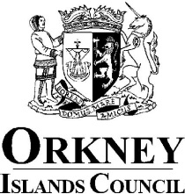

Register of Members’ Interests

Councillor: Janette Park

Ward: Stromness & South Isles

1. Remuneration
Director E Flett Butcher Ltd, 63 John Street, Stromness, KW16 3AD
SC498114

2. Other Roles
N/A

3. Contracts
N/A

4. Election Expenses
N/A

5. Houses, Land and Buildings
Stromness and South Isles
East Mainland, Burray and South Ronaldsay

6. Interest in Shares and Securities
50% of the ordinary share capital of E Flett Butcher Ltd

7. Gifts and Hospitality (N/A see paragraph 4.21 of Councillors’ Code of Conduct)
N/A

8. Non-Financial Interests
Honorary Curator, Stromness Museum, 52 Alfred Street, Stromness KW16 3DH SC021455
Director and Vice Chair, Stromness Community Development Trust. SC305725
Chair, Stromness Community Business Forum (ceased 21 May 2024)

9. Close Family Members
N/A

