
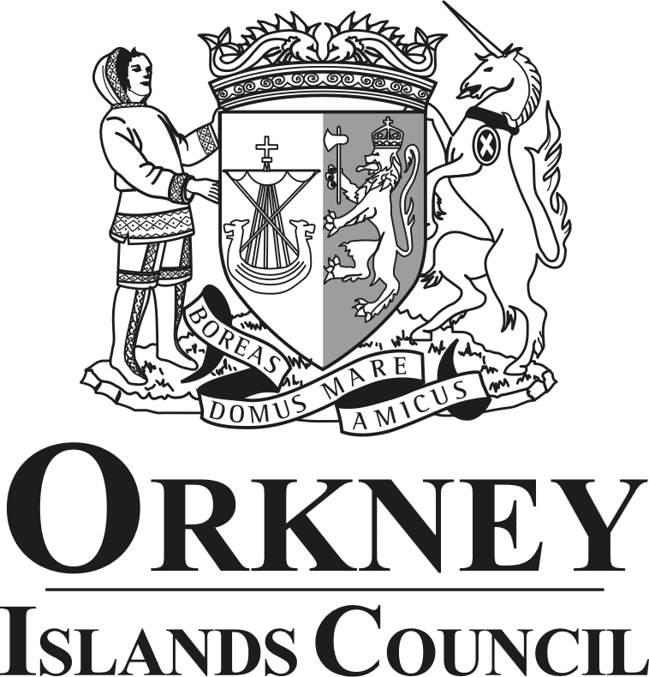
Equality Impact Assessment Template
The purpose of an Equality Impact Assessment (EqIA) is to improve the work of Orkney Islands Council by making sure it promotes equality and does not discriminate. This assessment records the likely impact of any changes to a proposal or changes by anticipating the consequences and making sure that any negative impacts are eliminated or minimised and positive impacts are maximised.
Should you have any questions or wish for your draft EqIA to be reviewed by our Equality, Diversity and Inclusion Adviser, please contact OD@orkney.gov.uk.
- Identification of the Proposal or Change

Name of proposal or change being assessed. | Section 12 and Section 22 Policy and Procedures.
Responsible Service and Directorate. | Orkney Health and Social Care Partnership.
Date of assessment. | 28 August 2025.
Is the proposal or change existing? (Please indicate if the service is to be deleted, reduced or changed significantly). | The Section 12 Policy and Procedure is a refresh, whilst the Section 22 Policy and Procedure is a new document.

- Primary Information
What are the intended outcomes of the proposal or change? | To ensure that clear Policies and Procedures are in place when assessing and awarding Section 12 and Section 22 funds.
Is the proposal or change strategically important? | No.
State who is or may be affected by this proposal or change, and how? | All applicants to the Section 12 and Section 22 financial assistance facilities.
How have stakeholders been involved in the development of this proposal or change? | There has been no consultation on these new Policies and Procedures.
Is there any existing data and / or research relating to equalities issues in this policy area? Please summarise.  E.g. consultations, national surveys, performance data, complaints, service user feedback, academic / consultants' reports, benchmarking. | No.
Is there any existing evidence relating to socio-economic disadvantage and inequalities of outcome in this policy area? Please summarise.  E.g. For people living in poverty or for people of low income. See The Fairer Scotland Duty Guidance for Public Bodies for further information. | No. However, these facilities are explicitly designed to assist those at a socio-economic disadvantage.
Could the proposal or change have a differential impact on any of the following equality areas? | Please provide any evidence – positive impacts / benefits, negative impacts and reasons:
1. Race: this includes ethnic or national groups, colour and nationality. | Yes. Those unable to speak English may need assistance to access these facilities.
2. Sex: a man or a woman. | No.
3. Sexual Orientation: whether a person's sexual attraction is towards their own sex, the opposite sex or to both sexes. | No.
4. Gender Reassignment: the process of transitioning from one gender to another. | No.
5. Pregnancy and maternity. | No.
6. Age: people of different ages. | Yes. However, the Section 12 fund is specifically for adults, whilst the Section 22 facility is specifically to assist adults with responsibility for a child(ren).
7. Religion or beliefs or none (atheists). | No.
8. Disability: people with disabilities (whether registered or not). | Yes. However, provision is made for those with disability to access both facilities.
9. Marriage and Civil Partnerships. | No.
10. Caring responsibilities | No.
11. Socio-economic disadvantage. | No. Both facilities are specifically designed to assist those with a socio-economic disadvantage.
12. Care experienced | No.

- Impact Assessment
Does the analysis above identify any differential impacts which need to be addressed? |  | No. All potential differential impacts have been addressed in the respective policies.
Does the analysis above identify any potential negative impacts? |  | No.
Do you have enough information to make a judgement? If no, what information do you require? |  | Yes.
- Equality Impact Assessment Action Plan
Please complete the following action plan where you have identified any differential impacts or potential negative impacts in Section 3 of the Equality Impact Assessment.

Impact Identified | Action to be taken |  | Owner | How will it be monitored | Date Action to be completed
Those unable to speak English will require assistance to access these facilities. | The Council’s translation service will provided should it be required. |  | Section 12 – Adult and Learning Disability Social Work.  Section 22 – Children and Families Field Work. | It is anticipated that very few non-English speaking service users will need to access the service. However, should this occur, officers will ensure the process is fully understood by the service user. | This will be addressed on an ad hoc basis.
Provision will be made for those disabled service users who may require assistance to access the service. | Support will be provided by the advocacy services, (currently provided by Who Cares? Scotland for Children, and Advocacy Orkney for Adults), or through the Orkney Health and Social Care Partnership’s disability services, as appropriate. |  | Section 12 – Adult and Learning Disability Social Work.  Section 22 – Children and Families Field Work. | This will be addressed on an ad hoc basis. | N/A.

- Sign and Date
Signature:

Name: | Shaun Hourston-Wells.
Date: | 28 August 2025.

