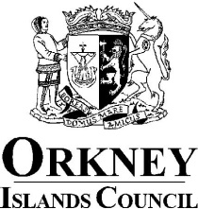

Register of Members’ Interests

Councillor: Lindsay Hall

Ward: Stromness and South Isles

Remuneration
- Hoy Energy Ltd - Annual retainer
- Statutory Pension and Local Government Pension - Monthly

Other Roles
• Island of Hoy Development Trust - Trustee
• Gable End Theatre Co Ltd - Treasurer
• Orkney Citizens Advice Bureau - Vice Chair (formally Chair) Resigned May 2022
• Citizens Advice Scotland - Trustee. Resigned May 2022
• Longhope Lifeboat Museum Trust – Former Secretary

Contracts
- None

Election Expenses
- Nil

Houses, Land and Buildings
- Joint Owner: 1 x property Stromness & South Isles

Interest in Shares and Securities
- None

Gifts and Hospitality (N/A see paragraph 4.21 of Councillors’ Code of Conduct)
- None

Non-Financial Interests
- None

9. Close Family Members
- None

