
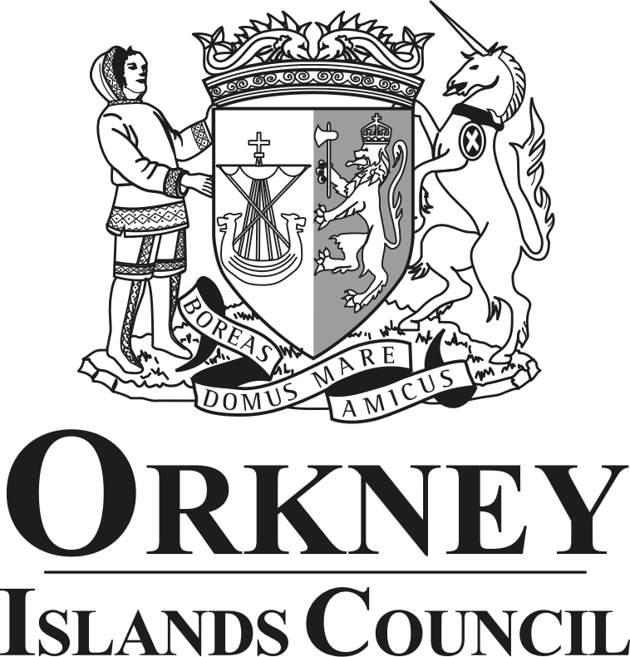
Equality Impact Assessment Template
The purpose of an Equality Impact Assessment (EqIA) is to improve the work of Orkney Islands Council by making sure it promotes equality and does not discriminate. This assessment records the likely impact of any changes to a proposal or changes by anticipating the consequences and making sure that any negative impacts are eliminated or minimised and positive impacts are maximised.
Should you have any questions or wish for your draft EqIA to be reviewed by our Equality, Diversity and Inclusion Adviser, please contact OD@orkney.gov.uk.
- Identification of the Proposal or Change

Name of proposal or change being assessed. | Throughcare and Aftercare Financial Policy and Procedure.
Responsible Service and Directorate. | Children and Families Authority Wide Services, Orkney Health and Social Care Partnership.
Date of assessment. | 8 September 2025.
Is the proposal or change existing? (Please indicate if the service is to be deleted, reduced or changed significantly). | A draft Throughcare and Aftercare Financial Policy and Procedure was proposed in 2021, however, this was never formally ratified through the Council’s governance processes.

- Primary Information
What are the intended outcomes of the proposal or change? | Ensure scrutiny and governance around Council expenditure and to ensure that financial practices in this area are consistent, equitable and minimise errors and misunderstanding.
Is the proposal or change strategically important? | No.
State who is or may be affected by this proposal or change, and how? | All young people receiving the support of the Throughcare/Aftercare Service.
How have stakeholders been involved in the development of this proposal or change? | Young people have not been directly involved in the composition of this Policy.
Is there any existing data and / or research relating to equalities issues in this policy area? Please summarise.  E.g. consultations, national surveys, performance data, complaints, service user feedback, academic / consultants' reports, benchmarking. | No.
Is there any existing evidence relating to socio-economic disadvantage and inequalities of outcome in this policy area? Please summarise.  E.g. For people living in poverty or for people of low income. See The Fairer Scotland Duty Guidance for Public Bodies for further information. | No. However, this new Policy will formalise the processes around financial support for young people, many of whom would be considered to be at a socio-economic disadvantage.
Could the proposal or change have a differential impact on any of the following equality areas? | Please provide any evidence – positive impacts / benefits, negative impacts and reasons:
1. Race: this includes ethnic or national groups, colour and nationality. | No.
2. Sex: a man or a woman. | No.
3. Sexual Orientation: whether a person's sexual attraction is towards their own sex, the opposite sex or to both sexes. | No.
4. Gender Reassignment: the process of transitioning from one gender to another. | No.
5. Pregnancy and maternity. | No.
6. Age: people of different ages. | Yes. This Policy is specifically to formalise a Financial Policy and Procedure around support for young people using the Throughcare/Aftercare Service.
7. Religion or beliefs or none (atheists). | No.
8. Disability: people with disabilities (whether registered or not). | No.
9. Marriage and Civil Partnerships. | No.
10. Caring responsibilities | No.
11. Socio-economic disadvantage. | Yes. This new Policy will formalise the processes around financial support for young people, many of whom would be considered to be at a socio-economic disadvantage.
12. Care experienced | No. However, many service users will be care experienced.

- Impact Assessment
Does the analysis above identify any differential impacts which need to be addressed? |  | No.
Does the analysis above identify any potential negative impacts? |  | No.
Do you have enough information to make a judgement? If no, what information do you require? |  | Yes.
- Equality Impact Assessment Action Plan
Please complete the following action plan where you have identified any differential impacts or potential negative impacts in Section 3 of the Equality Impact Assessment.

Impact Identified | Action to be taken |  | Owner | How will it be monitored | Date Action to be completed

- Sign and Date
Signature:

Name: | Shaun Hourston-Wells.
Date: | 8 September 2025.

