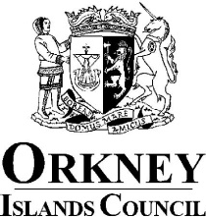

Register of Members’ Interests

Councillor: James Moar

Ward: East Mainland, South Ronaldsay and Burray

1. Remuneration
- Orkney Islands Council Elected Member
- Income from farm

2. Other Roles
- Relief B&L Builders until July 2022

3. Contracts
- None

4. Election Expenses
- Nil

5. Houses, Land and Buildings
- Farm of Rosebank Deerness, KW17 2QL
- Bayview Holm KW17 2RT

6. Interest in Shares and Securities
- None

7. Gifts and Hospitality (N/A see paragraph 4.21 of Councillors’ Code of Conduct)
- None

8. Non-Financial Interests
- None

9. Close Family Members
- Daughter works as Social Care Assistant as Short Breaks
- Daughter in law works as Administrative Assistant in Orkney Health and Care

